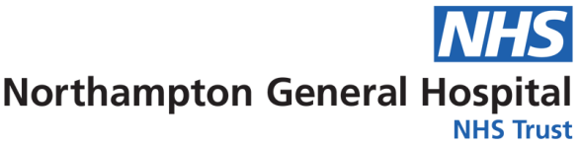
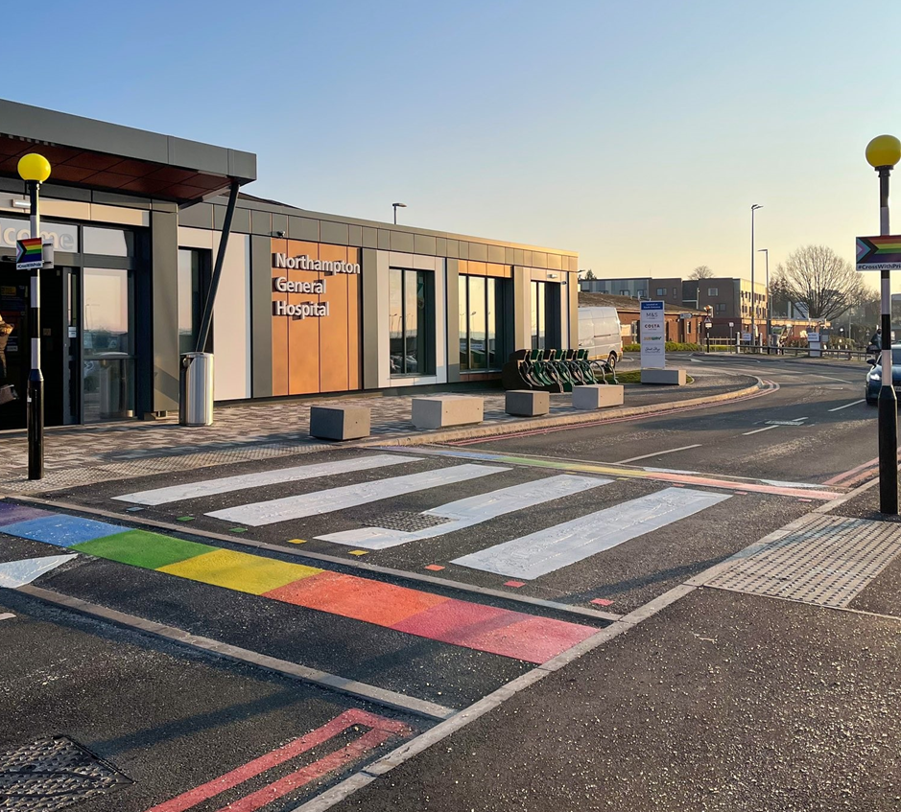
Equality, Diversity & Inclusion
Workforce Annual Report
April 2021 to March 2022
Equality and Diversity

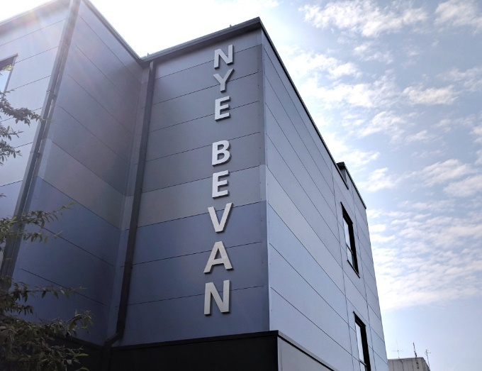
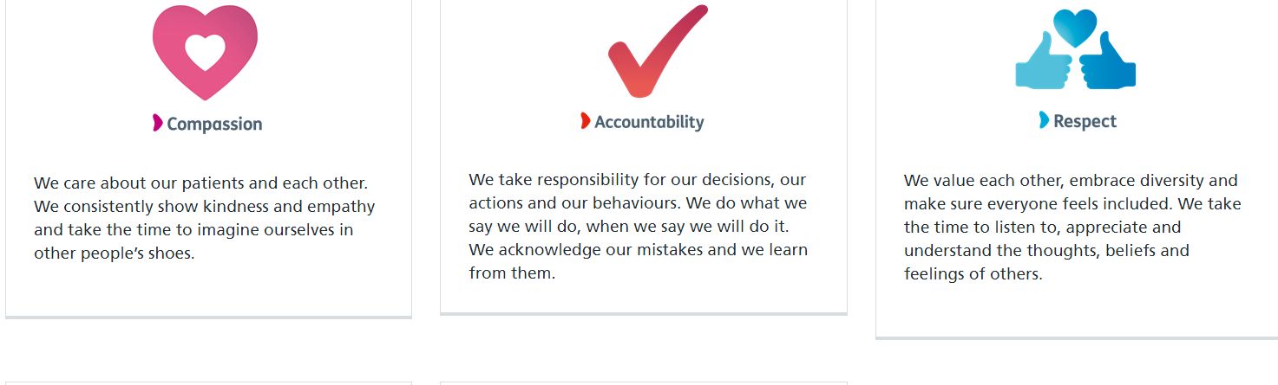
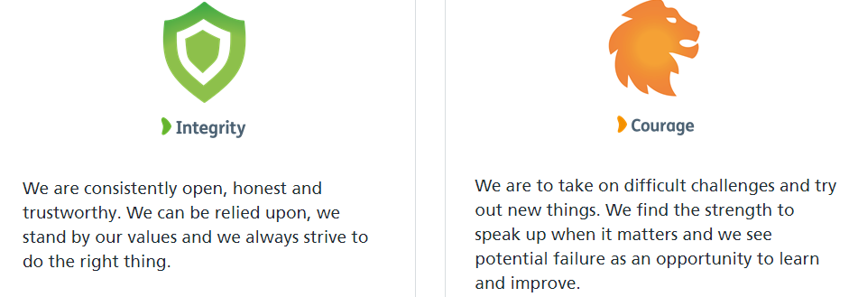
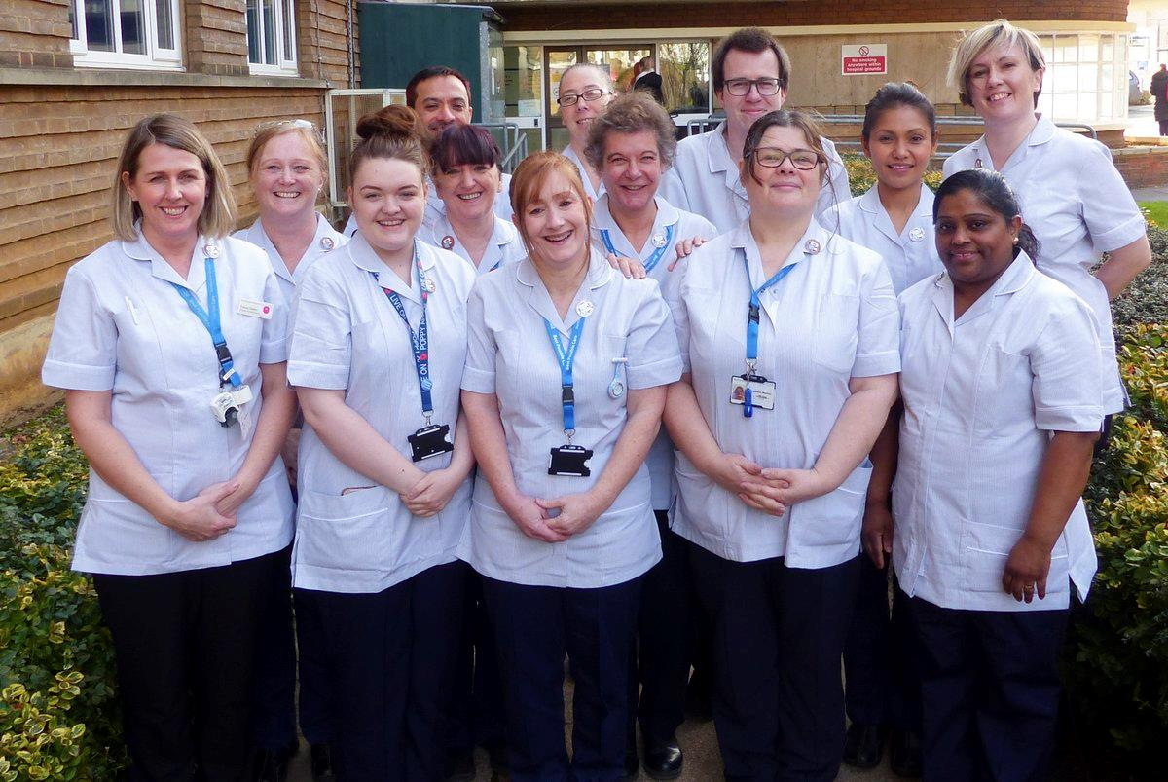
Contents
Our Vision, Mission and Excellence Values
Our Vision is - Dedicated to outstanding patient care and staff experience by becoming a University Hospital Group and a leader in clinical excellence, inclusivity and collaborative healthcare.

Our Mission is - To provide safe, compassionate and clinically excellent patient care, by being an outstanding employer for our people, by creating opportunities, supporting innovation, and by working in partnership to improve local health and care services.

Executive Summary 4

Introduction – Our Strategic Aims 5
2021/2022 Summary 6

Our Population 7

Our Colleagues 9
Our Activities 13
Our Workforce Data 19

Executive Summary

The Equality, Diversity and Inclusion Workforce Annual Report for 2021/2022 reviews the work Northampton General Hospital (NGH) has undertaken to promote equality, celebrate diversity create an inclusive workforce during April 2021 to March 2022.

On 1 July 2021 Northampton General Hospital and Kettering General Hospital formed the University Hospitals of Northamptonshire NHS Group which will enable us to work more closely together to provide our colleagues with a great place to work will, which in turn, enable us to meet our Mission, Vision and Values during 2021/2022 and the years ahead.

In July 2021 we approved our 2021-24 Group Equality, Diversity & Inclusion Strategy, providing a real focus on the work that the Trust needs to undertake as part of its commitment to become a truly inclusive employer for our people and our patients.

We are determined and committed to improve the experiences of teams by driving the necessary changes for people to truly be united in making NGH the best it can be – a place where people feel valued, respected and empowered. We want to work to make sure we keep the amazing staff we have and support them to implement change and feel valued at work, where they can bring their whole selves to work and be celebrated for everything they are.

We are also committed to encouraging our teams to think differently and explore ideas with them on how we can make NGH the best place to work and receive care. We have established a number of staff networks to ensure that we celebrate and embrace the diversity of teams. Our REACH (Race, Ethnicity & Cultural Heritage), DAWN (Disability & Wellbeing Network), PRIDE (LGBTQ+) and VOICE (NGH Women in Medicine) networks all support colleagues to have their voices heard and provide a space for us to all learn and improve how we do things here.

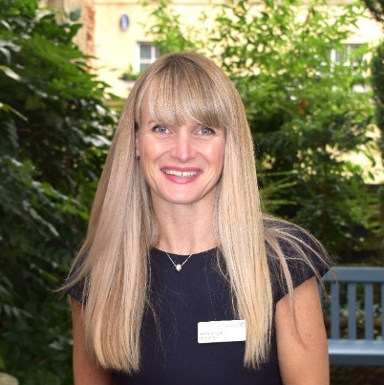

Heidi Smoult Alan Burns
Hospital CEO Chairman

Introduction – Our Strategic Aims

Equality, Diversity, and Inclusion (EDI) are key to achieving the Group vision of being dedicated to outstanding patient care and colleague experience by becoming a University Hospital Group and a leader in clinical excellence, inclusivity, and collaborative healthcare. The Group ambition is to be regarded as the best place for patient safety, quality and experience and the best place to work. The Group is committed to the elimination of discrimination, to reducing health inequalities, promoting equality of opportunity and dignity and respect for all our patients, their families, carers, and our colleagues.

We will model accountability and reflect changes to our practice to ensure we reach all our colleagues and model accessibility and inclusion in all we do through having
focussed and measurable action plan.

We believe that the Equality, Diversity, and Inclusion agenda is critical to building a future proof workforce that is truly reflective of the diverse communities we serve. We also believe that in building a diverse workforce, we will increase the talent pool from which we recruit and build services that are responsive to the needs of the local community.

We have five goals for the future:
- Creating a representative and supportive workforce
- Supporting accurate data collection and usage to measure and reduce inequalities
- Developing compassionate leadership and accountability
- Culture change through mainstreaming diversity and inclusion
- Improving Patient access and experience in and of our services

Further information regarding Equality, Diversity and Inclusion can be found on our website at https://www.northamptongeneral.nhs.uk/About/Equality-and-diversity-information/Equality-Diversity-Inclusion.aspx

A summary of some of our achievements during 2021/2022 can be found on the next page.

2021/2022 Summary

Strategy
Implementation of our Equality, Diversity and Inclusion Strategy commenced
Rainbow Badges
Selected as one of 40 Trusts on the National Rainbow Badge Phase 2.0 project with NHS England and Stonewall

Health & Wellbeing
Continued to provide culturally appropriate, tailored support to colleagues through our health & wellbeing, psychology and peer support provision
Inclusion Networks
Continued to work with and expand our Inclusion Networks to support more protected groups

Workforce Race Equality Standard (WRES)
Data collection undertaken and analysed for action planning on areas for improvement in conjunction with REACH group
Workforce Disability Equality Standard (WDES)
Data collection undertaken and analysed for action planning on areas for improvement in conjunction with DAWN group

#CrossWithPride
Permanent art installation on crossing outside trust South Entrance as a visual representation of support the Trust has for LGBTQ+ staff and patients
Support for Parenting Leave
200+ colleagues supported during to commence parenting leave

Our Population

Northampton General Hospital NHS Trust provides general acute services for a population of 380,000 and hyper-acute stroke, vascular and renal services to people living throughout whole of Northamptonshire, a population of 750,000. The Trust is also an accredited cancer centre and provides cancer services to a wider population of 880,000 who live in Northamptonshire and parts of Buckinghamshire.

The principal activity of the Trust is the provision of free healthcare to eligible patients. We are a hospital that provides the full range of outpatients, diagnostics, inpatient and day case elective and emergency care and also a growing range of specialist treatments that distinguishes our services from many district general hospitals. We also provide a very small amount of healthcare to private patients.

Northampton Population (2011 Census)

Age Group | Ethnic Group | Marital Status | Religion | Sex
0-17  22.8% | White  84.5% | Single  37.2% | Christian 56.6% | Male  49.5%
18-24  9.9% | Mixed  3.2% | Married  43.5% | Buddhist  0.4% | Female  50.5%
25-29  8.0% | Asian  6.5% | Civil Partnership 0.2% | Hindu  1.6%
30-44  22.2% | Black  5.1% | Separated  3.5% | Jewish  0.1%
45-59  18.4% | Other  0.7% | Divorced  9.5% | Muslim  4.2%
60-64  5.5% |  | Widowed  6.1% | Sikh  0.5%
65-74  7.0% |  |  | Other  0.5%
75-84  4.4% |  |  | No religion 29.4%
85+  1.9% |  |  | Not stated 6.7%

Our Colleagues

The Trust employs 5156.82 whole time equivalent (wte) colleagues, a headcount of 5814, (as at 31 March 2022).

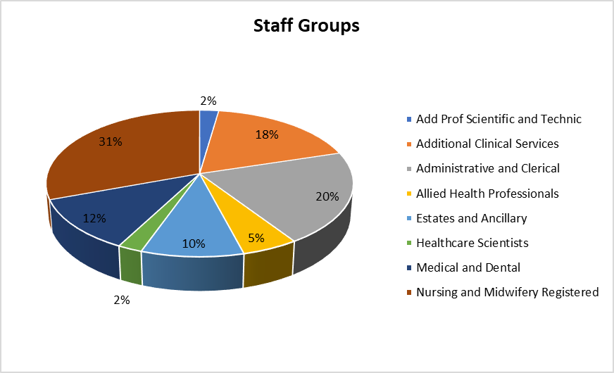

The breakdown of our colleagues, by the protected characteristics that data is recorded for, is detailed on the graphs below.

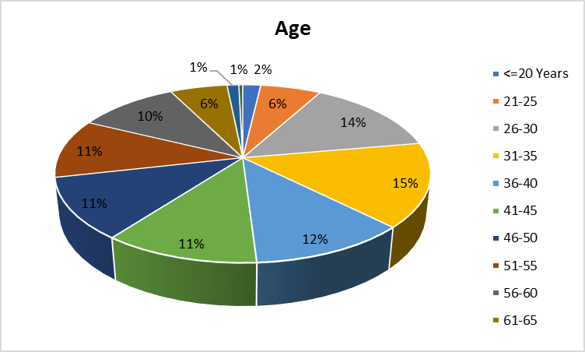

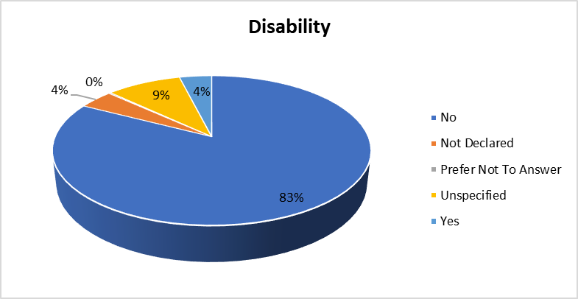
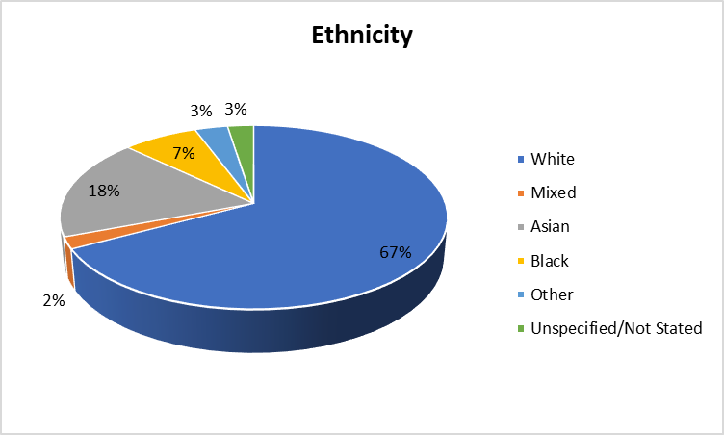
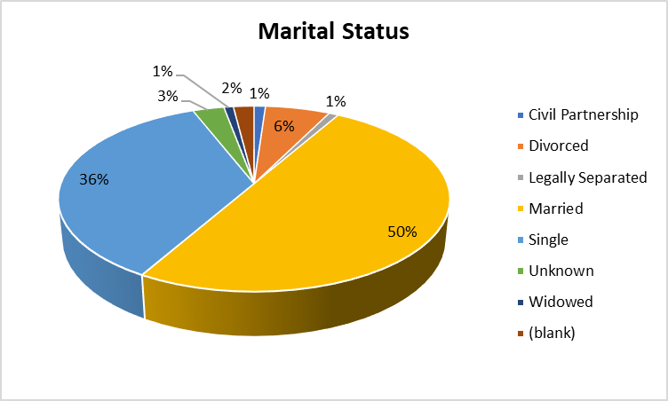

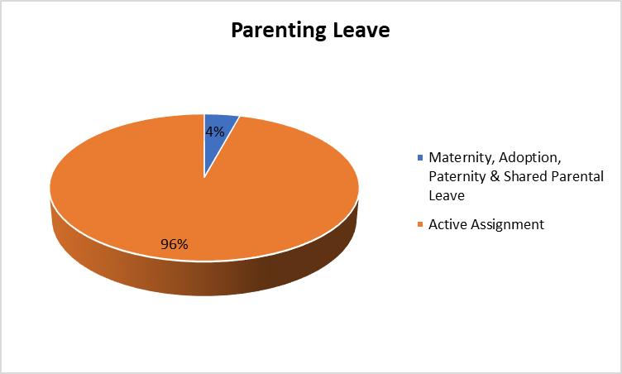
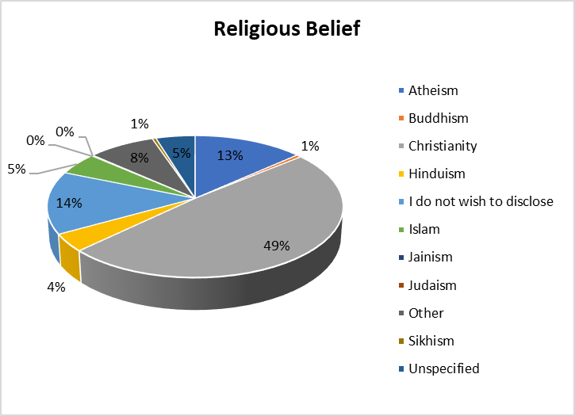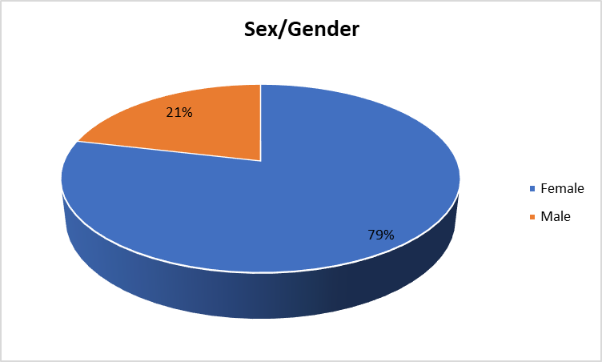

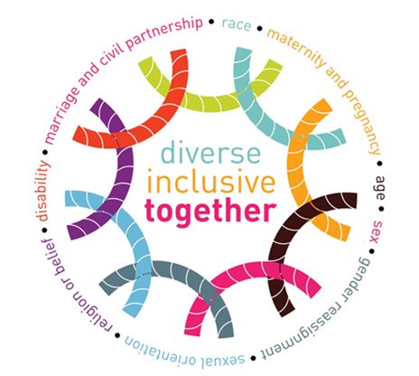

Our Activities

During 2020/21 we continued to work to and review our progress against our Equality, Diversity and Inclusion Strategy 2021-2024. The key areas of work and actions are linked to and driven by:

- Equality, Diversity and Inclusion Workforce Steering Group
- Inclusion Networks
- The Workforce Race Equality Standard (WRES)
- The Workforce Disability Standard (WDES)
- Gender Pay Gap Reporting
- National Staff Survey results
- Quarterly People Pulse results
- Freedom to Speak Up
- Promotion of equality, diversity and inclusion to increase awareness and cultural competence across all colleagues groups

Our key achievements included:

- The expansion of our REACH (Race, Equality & Cultural Heritage) Network and the introduction of DAWN (Disability & Wellbeing), Pride (LGBTQ+) Network and VOICE (NGH Women in Medicine) Network
- Celebration and promotion of key dates and events, including a permanent rainbow crossing art installation - #CrossWithPride
- Trained Champions in inclusive recruitment on all senior recruitment panels
- The introduction of a reverse mentoring programme with Trust Board members, starting with REACH Network, to be rolled out across all protected groups
- Continuing the BAME Clinical Fellow role to support our work with International Medical Graduates
- Recruitment of a Director of Nursing Fellow, specialising in Inclusive Leadership driving forward cultural projects for Internationally Educated Nurses
- 140 colleagues trained in Unconscious Bias
- Introduction of monthly Inclusion Newsletter showcasing all EDI training, celebration and learning opportunities
- Two REACH midwives won the RCM's Race Matters Award for their work in additional support to REACH women during the pandemic and successfully changed pregnancy outcomes
- Creation of Library of Diversity & Inclusion highlighting tools and resources encompassing all 9 protected characteristics
- The development of a joint approach with Kettering General Hospital in preparation for a Group EDI Strategy
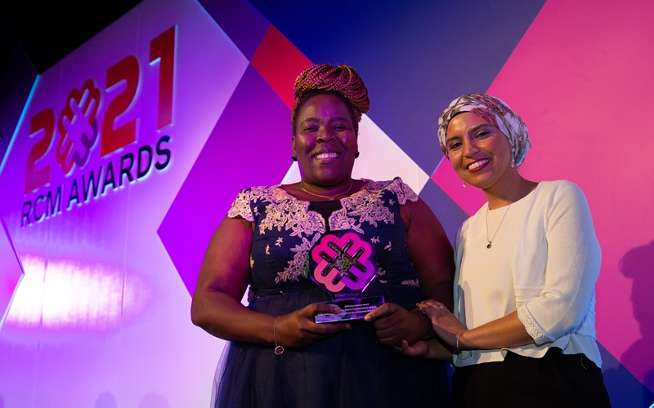
Samukeliso Sibanda, Chair of REACH (left) and Fatima Ghaouch (right), winning the Royal College of Midwives Race Matters Award in 2021

Workforce Race Equality Standard (WRES)

We undertook the data analysis exercise for the National Workforce Race Equality Standard (WRES) in 2021 and compared these results to those of 2020 to establish if there had been improvements or deteriorations in the experiences or the treatment of BME colleagues when compared to our White colleagues.

We showed improvement in:

- The number of BME colleagues we employee
- The total number of BME colleagues at a very senior manager level
- The likelihood of BME applicants being shortlisted when compared to White applicants
- BME colleagues experiencing bullying, harassment or abuse from patients, relatives or the public.
- BME colleagues experiencing bullying, harassment or abuse from other colleagues in the last 12 months
- BME colleagues believing career progression/promotion is fair when compared to White colleagues
- The percentage difference between our Board voting membership and our overall BME workforce, however despite this improvement our Trust Board does not reflect the overall ethnicity of our workforce.

Deteriorations were seen in:

- The likelihood of BME colleagues entering the formal disciplinary process, when compared to White colleagues
- The likelihood of BME colleagues accessing non-mandatory training/Continuous Professional Development when compared to White Colleagues
- BME colleagues experiencing discrimination form managers / team leaders / colleagues.

We acknowledge there is still work to do to improve the experiences and treatment of our BME workforce and we will be working closely with our REACH (Race, Ethnicity and Cultural Heritage) Inclusion Network to address the issues highlighted.

The National WRES Report was released in March 2021 and when comparing our results to the national results we better than the national findings in 2 areas and worse for the remaining 9 indicators.

Our WRES report can be accessed via our website.

Workforce Disability Equality Standard (WDES)

We undertook the data analysis exercise for the National Workforce Disability Equality Standard (WDES) in 2021 and compared these results to those of 2020 to establish if there had been improvements or deteriorations in the experiences or the treatment of disabled colleagues when compared to our non-disabled colleagues.

We showed improvement in:

- The number of disabled colleagues we employ
- Disabled colleagues experiencing bullying, harassment or abuse from patients, relatives or the public
- Disabled colleagues experiencing bullying, harassment or abuse from managers in the last 12 months
- Disabled colleagues or their colleagues reporting bullying, harassment or abuse
- Disabled colleagues saying that their employer has made adequate adjustments to enable them to carry out their work
- Colleagues Engagement score for disabled colleagues compared to non-disabled colleagues and the overall engagement score for the organisation.

Deteriorations were seen in:

- The likelihood of disabled applicants being shortlisted when compared to non-disabled applicants
- The likelihood of disabled colleagues entering the formal capability process, when compared to non-disabled colleagues
- Disabled colleagues experiencing bullying, harassment or abuse from other colleagues in the last 12 months
- Disabled colleagues believing career progression/promotion is fair when compared to non-disabled colleagues
- Disabled colleagues saying that they have felt pressure from their manager to come to work, despite not feeling well enough to perform their duties
- Disabled colleagues compared to non-disabled colleagues saying that they are satisfied with the extent to which their organisation values their work.

One area was unchanged from 2020, namely:

- The total number of disabled colleagues at a very senior manager level

We acknowledge there is still work to do to improve the experiences and treatment of our disabled workforce and we will be working closely with DAWN (Disability and Wellbeing Network) to address the issues highlighted.

Our WDES report can be accessed via our website.
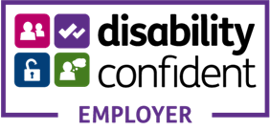

Gender Pay Gap Reporting

As per the Gender Pay Gap Information Regulations 2017, we compiled and analysed our data and submitted it to the Government in March 2022, as part of the requirements under the Regulations. Although we are not legally required to produce a written report, it was agreed this should be done to give context to the data and this will be published on our website.

There has been a deterioration in the gap since 2020. Resulting in female employees earning 88p for every £1 that a male employee earns.

Mean Hourly Rates, the difference and percentage pay gap, from 2020 to 2021
 | Mean Hourly Rate 2020 | Mean Hourly Rate 2021 | Mean Hourly Rate 2020/21 Variation
Male | £22.79 | £24.95 | +£2.16
Female | £16.42 | £16.96 | +£0.54
Difference | £6.37 | £7.99 | £1.62
Pay Gap | 27.9% | 32.0% | -4.1%

Median Hourly Rates, the difference & percentage pay gap, from 2020 to 2021
 | Median Hourly Rate 2020 | Median Hourly Rate 2021 | Median Hourly Rate 2020/21 Variation
Male | £16.23 | £17.24 | £1.01
Female | £14.37 | £15.10 | £0.73
Difference | £1.86 | £2.14 | £0.28
Pay Gap | 11.5% | 12.5% | -1.0%

We acknowledge there is a difference in the average pay of our male and female colleagues that needs to be addressed, which includes a greater female representation in our senior clinical roles.

Our Gender Pay Gap report can be accessed via our website.

Staff Survey 2021 Equality & Diversity Results

The demographics of our workforce who responded to the staff survey were broadly similar to our overall workforce with the exception of disabled colleagues where 25.83% of the respondents indicated they had a disability compared to the 4% of the workforce recorded on our systems.

For 2021 the reporting structure of the survey has changed and the results are now ‘themed’ in line with the national People Promise. Equality, Diversity and Inclusion sits within the ‘We are Compassionate and Inclusive; theme for which we scored 6.9 out of 10. We are below the national average of 7.2

Underpinning this theme there are 4 questions from the Staff Survey that contribute to the overall ‘theme’ result, in relation to Diversity and Equality:

Question 15 – Does your organisation act fairly with regard to career progression/promotion, regardless of ethnic background, gender, religion, sexual orientation, disability or age? There has been a deterioration of 2.3% since 2020 and we are worse than the national average by 4%. The national average has deteriorated by 0.5% since the 2020 survey.

Question 16a – In the last 12 months have you personally experienced discrimination at work from patients/service users, their relatives or other members of the public? There has been a deterioration 0.6% since 2020 and we are worse than the national average by 1.7%. The national average has deteriorated by 0.6% since the 2020 survey.

Question 16b –In the last 12 months have you personally experienced discrimination at work from managers/team leaders or other colleagues? There has been a deterioration of 2.1% since 2020 and we are worse than the national average by 4.1%. The national average has deteriorated by 0.8% since the 2020 survey.

Question 18 – I think my organization respects individual differences (e.g. cultures, working styles, backgrounds, ideas etc.) As a new question for 2021 there is no historical comparative data. We scored 63.4%, which was 5.4% below the national average.

The survey has highlighted some areas of concern and we will be working with our colleagues, trades unions and Inclusion Networks to understand the specific issues behind the results so that we can work together to create an inclusive environment where all colleagues are respected and valued.

Peris Nderitu, ED Junior Sister and member of REACH Network

Our Workforce Data

As at 31 March 2022 the Trust employed 5814 colleagues, which was a whole time equivalent of 5156.82 people.

By Colleagues Group breakdown is as follows:

Colleagues Group  (as at 31/3/22) | Headcount | %
Nursing and Midwifery Registered | 1781 | 30.63
Administrative and Clerical | 1192 | 20.50
Additional Clinical Services | 1042 | 17.92
Medical and Dental | 677 | 11.64
Estates and Ancillary | 553 | 9.51
Allied Health Professionals | 304 | 5.23
Healthcare Scientists | 133 | 2.29
Add Prof Scientific and Technic | 132 | 2.27
Total | 5814 | 100%

Age

The overall age profile for the Trust is shown in the table below:

Age Profile  (as at 31/3/22) | Headcount | %
0-20 | 107 | 1.84
21-25 | 359 | 6.17
26-30 | 827 | 14.22
31-35 | 886 | 15.24
36-40 | 670 | 11.52
41-45 | 659 | 11.33
46-50 | 647 | 11.13
51-55 | 627 | 10.78
56-60 | 599 | 10.30
61-65 | 340 | 5.85
66-70 | 70 | 1.20
71 & over | 23 | 0.40
Total | 5814 | 100%

The highest percentage of colleagues employed by the Trust are in the age ranges of 26-30 and 31-35. The lowest percentage of colleagues employed are in the age ranges of 71 and over and 66-70.

Age by Pay Band

Band | Age Group | Total | % | All Colleagues %
Bands 4 and Below | Under 20 | 107 | 4.48 | 1.84
 | 21-25 | 197 | 8.26 | 3.39
 | 26-30 | 260 | 10.90 | 4.47
 | 31-35 | 258 | 10.81 | 4.44
 | 36-40 | 259 | 10.85 | 4.45
 | 41-45 | 229 | 9.60 | 3.94
 | 46-50 | 231 | 9.68 | 3.97
 | 51-55 | 293 | 12.28 | 5.04
 | 56-60 | 300 | 12.57 | 5.16
 | Over 61 | 252 | 10.56 | 4.33
 | Total | 2386 | 100%
Bands 5-7 | Under 20 | 0 | n/a | n/a
 | 21-25 | 127 | 5.15 | 2.18
 | 26-30 | 413 | 16.73 | 7.10
 | 31-35 | 483 | 19.57 | 8.31
 | 36-40 | 303 | 12.28 | 5.21
 | 41-45 | 299 | 12.12 | 5.14
 | 46-50 | 284 | 11.51 | 4.88
 | 51-55 | 219 | 8.87 | 3.77
 | 56-60 | 204 | 8.27 | 3.51
 | Over 61 | 136 | 5.51 | 2.34
 | Total | 2509 | 100%
Band 8 and Above including VSM | Under 20 | 0 | n/a | n/a
 | 21-25 | 0 | n/a | n/a
 | 26-30 | 9 | 3.17 | 0.15
 | 31-35 | 19 | 6.69 | 0.33
 | 36-40 | 37 | 13.03 | 0.64
 | 41-45 | 44 | 15.49 | 0.76
 | 46-50 | 61 | 21.48 | 1.05
 | 51-55 | 49 | 17.25 | 0.84
 | 56-60 | 50 | 17.61 | 0.86
 | Over 61 | 15 | 5.28 | 0.26
 | Total | 284 | 100%
Medical & Dental | Under 20 | 0 | n/a | n/a
 | 21-25 | 35 | 5.18 | 0.60
 | 26-30 | 145 | 21.45 | 2.49
 | 31-35 | 126 | 18.64 | 2.17
 | 36-40 | 71 | 10.50 | 1.22
 | 41-45 | 87 | 12.87 | 1.50
 | 46-50 | 71 | 10.50 | 1.22
 | 51-55 | 66 | 9.76 | 1.14
 | 56-60 | 45 | 6.66 | 0.77
 | Over 61 | 30 | 4.44 | 0.52
 | Total | 636 | 100%

Age by New Starters

Between 1 April 2021 and 31 March 2022 there were 1422 new starters at the Trust.

Age Profile of New Starters  (as at 31/3/22) | Headcount | %
0-20 | 119 | 8.37
21-25 | 204 | 14.35
26-30 | 276 | 19.41
30-35 | 238 | 16.74
36-40 | 150 | 10.55
41-45 | 117 | 8.23
46-50 | 87 | 6.12
51-55 | 84 | 5.91
56-60 | 75 | 5.27
61-65 | 51 | 3.59
66-70 | 19 | 1.34
71 & over | 2 | 0.14
Total | 1422 | 100%

Age by Leavers

Between 1 April 2021 and 31 March 2022 there were 981 leavers from the Trust.

Age Profile of Leavers  (as at 31/3/22) | Headcount | %
0-20 | 34 | 3.47
21-25 | 124 | 12.64
26-30 | 189 | 19.27
30-35 | 140 | 14.27
36-40 | 108 | 11.01
41-45 | 77 | 7.85
46-50 | 56 | 5.71
51-55 | 62 | 6.32
56-60 | 85 | 8.66
61-65 | 67 | 6.83
66-70 | 32 | 3.26
71 & over | 7 | 0.71
Total | 981 | 100%

Disability

The overall disability profile for the Trust is shown in the table below:

Disability Profile  (as at 31/3/22) | Headcount | %
No | 4804 | 82.63
Not Declared | 242 | 4.16
Prefer Not to Answer | 14 | 0.24
Unspecified | 527 | 9.06
Yes | 227 | 3.90
Total | 5814 | 100%

The highest percentage of colleagues employed by the Trust have declared they do not have a disability. The lowest percentage of colleagues employed have indicated they would prefer not to answer.

Disability by Pay Band

Band | Disability | Total | % | All Colleagues %
Bands 4 and Below | No | 1973 | 82.69 | 33.94
 | Not Declared | 69 | 2.89 | 1.19
 | Prefer Not to Answer | 3 | 0.13 | 0.05
 | Unspecified | 230 | 9.64 | 3.96
 | Yes | 111 | 4.65 | 1.91
 | Total | 2386 | 100%
Bands 5-7 | No | 2051 | 83.10 | 35.28
 | Not Declared | 108 | 4.38 | 1.86
 | Prefer Not to Answer | 9 | 0.36 | 0.15
 | Unspecified | 211 | 8.55 | 3.63
 | Yes | 89 | 3.61 | 1.53
 | Total | 2468 | 100%
Band 8 and Above including VSM | No | 230 | 80.99 | 3.96
 | Not Declared | 12 | 4.23 | 0.21
 | Prefer Not to Answer | 0 | n/a | n/a
 | Unspecified | 32 | 11.27 | 0.55
 | Yes | 10 | 3.52 | 0.17
 | Total | 284 | 100%
Medical & Dental | No | 550 | 81.36 | 9.46
 | Not Declared | 53 | 7.84 | 0.91
 | Prefer Not to Answer | 2 | 0.30 | 0.03
 | Unspecified | 54 | 7.99 | 0.93
 | Yes | 17 | 2.51 | 0.29
 | Total | 676 | 100%

Disability by New Starters

Between 1 April 2021 and 31 March 2022 there were 1422 new starters at the Trust.

Disability Profile of New Starters  (as at 31/3/22) | Headcount | %
No | 1160 | 81.58
Not Declared | 37 | 2.60
Prefer Not to Answer | 1 | 0.07
Unspecified | 176 | 12.38
Yes | 48 | 3.38
Total | 1422 | 100%

Disability by Leavers

Between 1 April 2021 and 31 March 2022 there were 981 leavers from the Trust.

Disability Profile of Leavers  (as at 31/3/22) | Headcount | %
No | 822 | 83.79
Not Declared | 64 | 6.52
Prefer Not to Answer | 2 | 0.20
Unspecified | 61 | 6.22
Yes | 32 | 3.26
Total | 981 | 100%

Ethnicity

The overall ethnicity profile for the Trust is shown in the table below:

Ethnicity Profile  (as at 31/3/22) | Headcount | %
White | 3906 | 67.18
Mixed | 120 | 2.06
Asian | 1037 | 17.84
Black | 421 | 7.24
Other | 184 | 3.16
Not Stated / Specified | 146 | 2.51
Total | 5814 | 100%

The highest percentage of colleagues employed by the Trust are White and Asian. The lowest percentage of colleagues employed are Mixed, Other or Have Not Stated/Specified.

Ethnicity by Pay Band

Band | Ethnicity | Total | % | All Colleagues %
Bands 4 and Below | White | 1940 | 81.31 | 33.37
 | Mixed | 53 | 2.22 | 0.91
 | Asian | 182 | 7.63 | 3.13
 | Black | 131 | 5.49 | 2.25
 | Other | 28 | 1.17 | 0.48
 | Not Stated / Specified | 52 | 2.18 | 0.89
 | Total | 2386 | 100%
Bands 5-7 | White | 1495 | 60.58 | 25.71
 | Mixed | 41 | 1.66 | 0.71
 | Asian | 534 | 21.64 | 9.18
 | Black | 230 | 9.32 | 3.96
 | Other | 105 | 4.25 | 1.81
 | Not Stated / Specified | 63 | 2.55 | 1.08
 | Total | 2468 | 100%
Band 8 and Above including VSM | White | 246 | 86.62 | 4.23
 | Mixed | 3 | 1.06 | 0.05
 | Asian | 19 | 6.69 | 0.33
 | Black | 7 | 2.46 | 0.12
 | Other | 5 | 1.76 | 0.09
 | Not Stated / Specified | 4 | 1.41 | 0.07
 | Total | 284 | 100%
Medical & Dental | White | 225 | 33.28 | 3.87
 | Mixed | 23 | 3.40 | 0.40
 | Asian | 302 | 44.67 | 5.19
 | Black | 53 | 7.84 | 0.91
 | Other | 46 | 6.80 | 0.79
 | Not Stated / Specified | 27 | 3.99 | 0.46
 | Total | 676 | 100%

Ethnicity by New Starters

Between 1 April 2021 and 31 March 2022 there were 1422 new starters at the Trust.

Ethnicity Profile of New Starters  (as at 31/3/22) | Headcount | %
White | 755 | 53.09
Mixed | 42 | 2.95
Asian | 316 | 22.22
Black | 141 | 9.92
Other | 67 | 4.71
Unspecified | 75 | 5.27
Not Stated | 26 | 1.83
Total | 1422 | 100%

Ethnicity by Leavers

Between 1 April 2021 and 31 March 2022 there were 981 leavers from the Trust.

Ethnicity Profile of Leavers  (as at 31/3/22) | Headcount | %
White | 612 | 62.39
Mixed | 17 | 1.73
Asian | 164 | 16.72
Black | 104 | 10.60
Other | 39 | 3.98
Unspecified | 8 | 0.82
Not Stated | 37 | 3.77
Total | 981 | 100%

Marital Status

The overall marital status profile for the Trust is shown in the table below:

Marital Status Profile  (as at 31/3/22) | Headcount | %
Civil Partnership | 64 | 1.10
Divorced | 363 | 6.24
Legally Separated | 54 | 0.93
Married | 2907 | 50.00
Single | 2081 | 35.79
Unknown | 176 | 3.03
Widowed | 53 | 0.91
Blank | 116 | 2.00
Total | 5814 | 100%

The highest percentage of colleagues employed by the Trust are married or single. The lowest percentage of colleagues employed are in a civil partnership, legally separated or widowed.

Marital Status by Pay Band

Band | Marital Status | Total | % | All Colleagues %
Bands 4 and Below | Civil Partnership | 38 | 1.59 | 0.65
 | Divorced | 197 | 8.26 | 3.39
 | Legally Separated | 36 | 1.51 | 0.62
 | Married | 1031 | 43.21 | 17.73
 | Single | 971 | 40.70 | 16.70
 | Unknown | 81 | 3.39 | 1.39
 | Widowed | 32 | 1.34 | 0.55
 | Total | 2386 | 100%
Bands 5-7 | Civil Partnership | 19 | 0.77 | 0.33
 | Divorced | 132 | 5.35 | 2.27
 | Legally Separated | 13 | 0.53 | 0.22
 | Married | 1322 | 53.57 | 22.74
 | Single | 871 | 35.29 | 14.98
 | Unknown | 92 | 3.73 | 1.58
 | Widowed | 19 | 0.77 | 0.33
 | Total | 2468 | 100%
Band 8 and Above including VSM | Civil Partnership | 4 | 1.41 | 0.07
 | Divorced | 23 | 8.10 | 0.40
 | Legally Separated | 4 | 1.41 | 0.07
 | Married | 187 | 65.85 | 3.22
 | Single | 54 | 19.01 | 0.93
 | Unknown | 10 | 3.52 | 0.17
 | Widowed | 2 | 0.70 | 0.03
 | Total | 284 | 100%
Medical & Dental | Civil Partnership | 3 | 0.44 | 0.05
 | Divorced | 11 | 1.63 | 0.19
 | Legally Separated | 1 | 0.15 | 0.02
 | Married | 367 | 54.29 | 6.31
 | Single | 185 | 27.37 | 3.18
 | Unknown | 108 | 15.98 | 1.86
 | Widowed | 1 | 0.15 | 0.02
 | Total | 676 | 100%

Marital Status by New Starters

Between 1 April 2021 and 31 March 2022 there were 1422 new starters at the Trust.

Marital Status Profile of New Starters  (as at 31/3/22) | Headcount | %
Civil Partnership | 18 | 1.27
Divorced | 55 | 3.87
Legally Separated | 11 | 0.77
Married | 518 | 36.43
Single | 644 | 45.29
Unknown | 46 | 3.23
Widowed | 8 | 0.56
Blank | 122 | 8.58
Total | 1422 | 100%

Marital Status by Leavers

Between 1 April 2021 and 31 March 2022 there were 981 leavers from the Trust.

Marital Status Profile of Leavers  (as at 31/3/22) | Headcount | %
Civil Partnership | 14 | 1.43
Divorced | 47 | 4.79
Legally Separated | 8 | 0.82
Married | 392 | 39.96
Single | 454 | 46.28
Unknown | 38 | 3.87
Widowed | 7 | 0.71
Blank | 21 | 2.14
Total | 981 | 100%

Maternity

The overall maternity status profile for the Trust, including paternity leave, adoption and shared parental leave is shown in the table below:

Maternity Leave Status Profile  (commenced between 1/4/21 and 31/3/22) | Headcount | % of Trust Colleagues
Maternity Leave | 201 | 3.46
Paternity Leave | 39 | 0.67
Shared Parental Leave | 6 | 0.10
Adoption Leave | 0 | 0
Total | 246 | 4.23%

The highest percentage of colleagues on parenting leave commenced maternity leave.

Religious Belief

The overall religious belief profile for the Trust is shown in the table below:

Religious Belief Profile  (as at 31/3/22) | Headcount | %
Atheism | 779 | 13.40
Buddhism | 35 | 0.60
Christianity | 2842 | 48.88
Hinduism | 236 | 4.06
I Do Not Wish to Disclose | 831 | 14.29
Islam | 298 | 5.13
Jainism | 4 | 0.07
Judaism | 7 | 0.12
Other | 478 | 8.22
Sikhism | 26 | 0.45
Unspecified | 278 | 4.78
Total | 5814 | 100%

The highest percentage of colleagues employed by the Trust are Christian and I Do Not Wish to Disclose. The religious beliefs of the lowest percentage of colleagues employed are Jainism and Judaism.

Religious Belief by Pay Band

Band | Religious Belief | Total | % | All Colleagues %
Bands 4 and Below | Atheism | 375 | 15.72 | 6.45
 | Buddhism | 10 | 0.42 | 0.17
 | Christianity | 1161 | 48.66 | 19.97
 | Hinduism | 34 | 1.42 | 0.58
 | Not Disclosed | 366 | 15.34 | 6.30
 | Islam | 58 | 2.43 | 1.00
 | Jainism | 1 | 0.04 | 0.02
 | Judaism | 1 | 0.04 | 0.02
 | Other | 258 | 10.81 | 4.44
 | Sikhism | 5 | 0.21 | 0.09
 | Unspecified | 117 | 4.90 | 2.01
 | Total | 2386 | 100%
Bands 5-7 | Atheism | 303 | 12.28 | 5.21
 | Buddhism | 8 | 0.32 | 0.14
 | Christianity | 1391 | 56.36 | 23.93
 | Hinduism | 82 | 3.32 | 1.41
 | Not Disclosed | 337 | 13.65 | 5.80
 | Islam | 50 | 2.03 | 0.86
 | Jainism | 0 | n/a | n/a
 | Judaism | 2 | 0.08 | 0.03
 | Other | 182 | 7.37 | 3.13
 | Sikhism | 12 | 0.49 | 0.21
 | Unspecified | 101 | 4.09 | 1.74
 | Total | 2468 | 100%
Band 8 and Above including VSM | Atheism | 49 | 17.25 | 0.84
 | Buddhism | 1 | 0.35 | 0.02
 | Christianity | 143 | 50.35 | 2.46
 | Hinduism | 4 | 1.41 | 0.07
 | Not Disclosed | 34 | 11.97 | 0.58
 | Islam | 9 | 3.17 | 0.15
 | Jainism | 2 | 0.70 | 0.03
 | Judaism | 0 | n/a | n/a
 | Other | 25 | 8.80 | 0.43
 | Sikhism | 2 | 0.70 | 0.03
 | Unspecified | 15 | 5.28 | 0.26
 | Total | 284 | 100%
Medical & Dental | Atheism | 52 | 7.69 | 0.89
 | Buddhism | 16 | 2.37 | 0.28
 | Christianity | 147 | 21.75 | 2.53
 | Hinduism | 116 | 17.16 | 2.00
 | Not Disclosed | 94 | 13.91 | 1.62
 | Islam | 181 | 26.78 | 3.11
 | Jainism | 1 | 0.15 | 0.02
 | Judaism | 4 | 0.59 | 0.07
 | Other | 13 | 1.92 | 0.22
 | Sikhism | 7 | 1.04 | 0.12
 | Unspecified | 45 | 6.66 | 0.77
 | Total | 676 | 100%
Religious Belief by New Starters

Between 1 April 2021 and 31 March 2022 there were 1422 new starters at the Trust.

Religious Belief Profile of New Starters  (as at 31/3/22) | Headcount | %
Atheism | 183 | 12.87
Buddhism | 14 | 0.98
Christianity | 455 | 32.00
Hinduism | 82 | 5.77
Not Disclosed | 368 | 25.88
Islam | 173 | 12.17
Judaism | 2 | 0.14
Other | 85 | 5.98
Sikhism | 14 | 0.98
Unspecified | 46 | 3.23
Total | 1422 | 100%

Religious Belief by Leavers

Between 1 April 2021 and 31 March 2022 there were 981 leavers from the Trust.

Religious Belief Profile of Leavers  (as at 31/3/22) | Headcount | %
Atheism | 124 | 12.64
Buddhism | 12 | 1.22
Christianity | 406 | 41.39
Hinduism | 48 | 4.89
Not Disclosed | 153 | 15.60
Islam | 101 | 10.30
Jainism | 1 | 0.10
Judaism | 3 | 0.31
Other | 85 | 8.66
Sikhism | 7 | 0.71
Unspecified | 41 | 4.18
Total | 981 | 100%

Sex/Gender

The overall sex/gender profile for the Trust is shown in the table below:

Sex/Gender Profile  (as at 31/3/22) | Headcount | %
Female | 4572 | 78.64
Male | 1242 | 21.36
Total | 5814 | 100%

The highest percentage of colleagues employed by the Trust are female.

Sex/Gender by Pay Band

Band | Sex/Gender | Total | % | All Colleagues %
Bands 4 and Below | Female | 1924 | 80.64 | 33.09
 | Male | 462 | 19.36 | 7.95
 | Total | 2386 | 100%
Bands 5-7 | Female | 2143 | 86.83 | 36.86
 | Male | 325 | 13.17 | 5.59
 | Total | 2468 | 100%
Band 8 and Above including VSM | Female | 217 | 76.41 | 3.73
 | Male | 67 | 23.59 | 1.15
 | Total | 284 | 100%
Medical & Dental | Female | 288 | 42.60 | 4.95
 | Male | 388 | 57.40 | 6.67
 | Total | 676 | 100%

Sex/Gender by New Starters

Between 1 April 2021 and 31 March 2022 there were 1422 new starters at the Trust.

Sex/Gender Profile of New Starters  (as at 31/3/22) | Headcount | %
Female | 1021 | 71.80
Male | 401 | 28.20
Total | 1422 | 100%

Sex/Gender by Leavers

Between 1 April 2021 and 31 March 2022 there were 981 leavers from the Trust.

Sex/Gender Profile of Leavers  (as at 31/3/22) | Headcount | %
Female | 713 | 72.68
Male | 268 | 27.32
Total | 981 | 100%

Sexual Orientation

The overall sexual orientation profile for the Trust is shown in the table below:

Sexual Orientation Profile  (as at 31/3/22) | Headcount | %
Bisexual | 56 | 0.96
Gay or Lesbian | 82 | 1.41
Heterosexual or Straight | 4740 | 81.53
Not Stated | 622 | 10.70
Other Sexual Orientation | 10 | 0.17
Undecided | 5 | 0.09
Unspecified | 299 | 5.14
Total | 5814 | 100%

The highest percentage of colleagues employed by the Trust are Heterosexual or Straight or have Not Stated. The sexual orientation of the lowest percentage of colleagues employed is Undecided or Other Sexual Orientation.

Sexual Orientation by Pay Band

Band | Sexual Orientation | Total | % | All Colleagues %
Bands 4 and Below | Bisexual | 30 | 1.26 | 0.52
 | Gay or Lesbian | 43 | 1.80 | 0.74
 | Heterosexual or Straight | 1945 | 81.52 | 33.45
 | Not stated | 236 | 9.89 | 4.06
 | Other sexual orientation | 7 | 0.29 | 0.12
 | Undecided | 2 | 0.08 | 0.03
 | Unspecified | 123 | 5.16 | 2.12
 | Total | 2386 | 100%
Bands 5-7 | Bisexual | 23 | 0.93 | 0.40
 | Gay or Lesbian | 32 | 1.30 | 0.55
 | Heterosexual or Straight | 2019 | 81.81 | 34.73
 | Not stated | 276 | 11.18 | 4.75
 | Other sexual orientation | 2 | 0.08 | 0.03
 | Undecided | 2 | 0.08 | 0.03
 | Unspecified | 114 | 4.62 | 1.96
 | Total | 2468 | 100%
Band 8 and Above including VSM | Bisexual | 1 | 0.35 | 0.02
 | Gay or Lesbian | 4 | 1.41 | 0.07
 | Heterosexual or Straight | 236 | 83.10 | 4.06
 | Not stated | 26 | 9.15 | 0.45
 | Other sexual orientation | 0 | n/a | n/a
 | Undecided | 0 | n/a | n/a
 | Unspecified | 17 | 5.99 | 0.29
 | Total | 284 | 100%
Medical & Dental | Bisexual | 2 | 0.30 | 0.03
 | Gay or Lesbian | 3 | 0.44 | 0.05
 | Heterosexual or Straight | 540 | 79.88 | 9.29
 | Not stated | 84 | 12.43 | 1.44
 | Other sexual orientation | 1 | 0.15 | 0.02
 | Undecided | 1 | 0.15 | 0.02
 | Unspecified | 45 | 6.66 | 0.77
 | Total | 676 | 100%

Sexual Orientation by New Starters

Between 1 April 2021 and 31 March 2022 there were 1422 new starters at the Trust.

Sexual Orientation of New Starters  (as at 31/3/22) | Headcount | %
Bisexual | 15 | 1.05
Gay or Lesbian | 21 | 1.48
Heterosexual or Straight | 1015 | 71.38
Not stated | 318 | 22.36
Other sexual orientation | 6 | 0.42
Undecided | 1 | 0.07
Unspecified | 46 | 3.23
Total | 1422 | 100%

Sexual Orientation by Leavers

Between 1 April 2021 and 31 March 2022 there were 981 leavers from the Trust.

Sexual Orientation Profile of Leavers  (as at 31/3/22) | Headcount | %
Bisexual | 10 | 1.02
Gay or Lesbian | 11 | 1.12
Heterosexual or Straight | 805 | 82.06
Not stated | 112 | 11.42
Undecided | 1 | 0.10
Unspecified | 42 | 4.28
Total | 981 | 100%

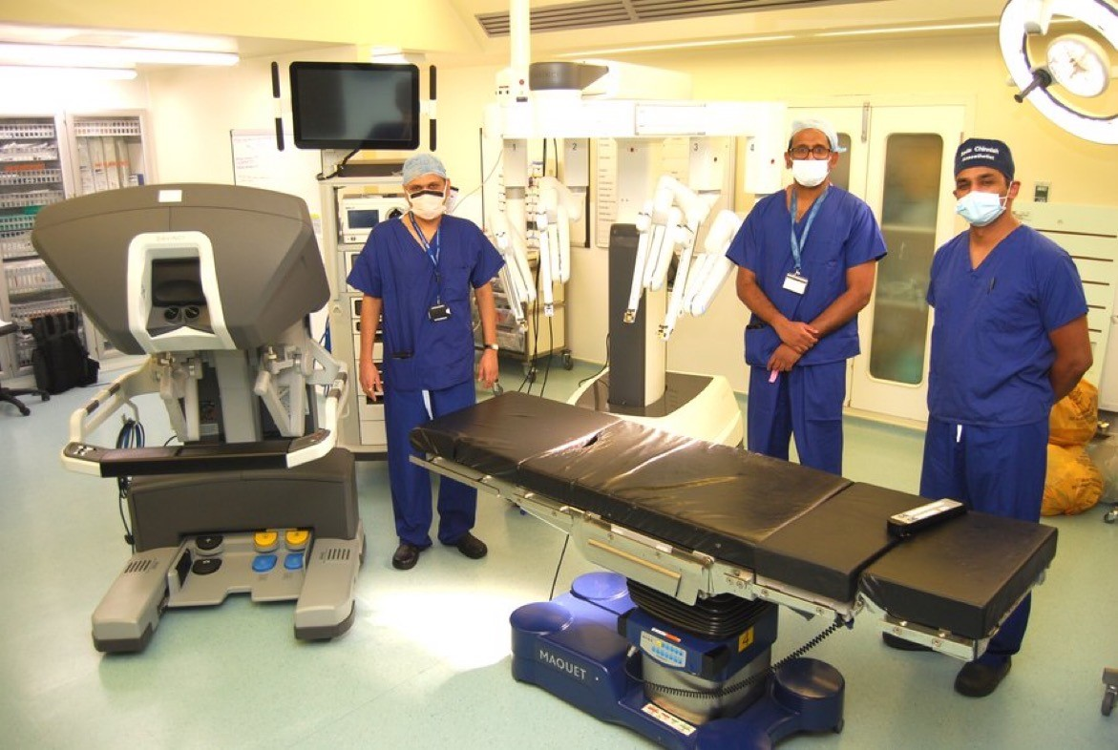

Northampton General Hospital NHS Trust

Our Contact Details are:

- Cliftonville, Northampton, NN1 5BD
- 01604 634700
- www.ngh.nhs.uk
- Find us on Facebook
- Follow us on Twitter @nghnhstrust
- Follow us on Instagram

