**Gender Pay Gap Report 2024**

**Reporting on the snapshot date of 31 March 2023**

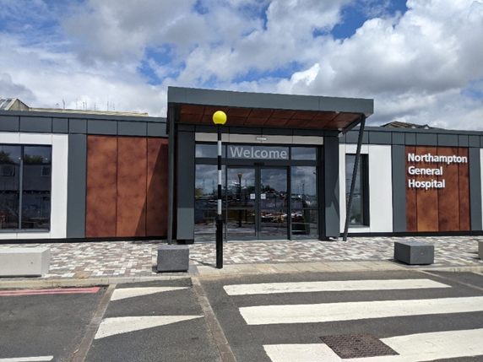

A photograph of the entrance to Northampton General Hospital

**Introduction**

In line with the Equality Act 2010 (Gender Pay Gap Information Regulations 2017), Northampton General Hospital NHS Trust has undertaken gender pay gap reporting on the snapshot date of 31 March 2023.

The Trust has calculated the following for its employees and workers:

* The mean gender pay gap
* The median gender pay gap
* The mean bonus gender pay gap
* The median bonus gender pay gap
* The proportion of males receiving a bonus payment
* The proportion of females receiving a bonus payment
* The proportion of males and females in each quartile pay band

At the time the snapshot was taken the Trust had 5965 employees, of which 4643 (77.8%) were female and 1,322 (22.2%) were male.

Compared to the 2023 report the workforce has decreased by 73. The female workforce has decreased by 126 and the male workforce has increased by 53.

The ratio of male to female colleagues that the Trust has is commonplace for an acute district general hospital such as Northampton.

The greatest proportion of colleagues at the Trust are Nurses, Midwives and Healthcare Assistants and the majority of these colleagues are female. Data from the Nursing and Midwifery Council (NMC) supports this and in their mid-year update (1 April–30 September 2023) the NMC reported that 88.7% of the people on their register identified as female, while 11.3% identified as male.

**NHS Pay Structure**

The majority of colleagues at the Trust are on the national Agenda for Change Terms and Conditions of Service. The basic pay structure for these colleagues is across 8 pay bands and colleagues are assigned to one of these pay bands on the basis of job weight, as measured by the NHS Job Evaluation Scheme. Within each band there are a number of incremental pay progression points as agreed by the NHS National Staff Council.

Medical and Dental colleagues have different sets of Terms and Conditions of Service, depending on seniority. These too are set across a number of pay scales, for basic pay, which have varying numbers of thresholds within them.

There are separate arrangements for Very Senior Managers, such as Chief Executives, Directors and other senior managers who are not on an Agenda for Change Terms and Conditions of Service.

As a public sector organisation, some of the services that are provided are on a 24/7 basis and therefore colleagues that work unsocial hours, participate in on-call rotas and work on general public holidays will also be in receipt of enhanced pay in addition to their basic pay. This mainly applies to clinical colleagues who work in ward areas along with non-clinical senior managers, who participate in the Senior Manager/Executive on-call rota and non-clinical colleagues who provide 24/7 services such as Estates and auxiliary colleagues.

The Trust does have a number of clinical departments that do not provide 24/7 such as clinics and outpatient areas and therefore these colleagues roles may not attract enhancements.

**The Overall Pay Gap**

In our organisation, women earn 95p for every £1 that men earn when comparing median hourly pay. This is an improvement from the previous year where it was 91p for every £1.

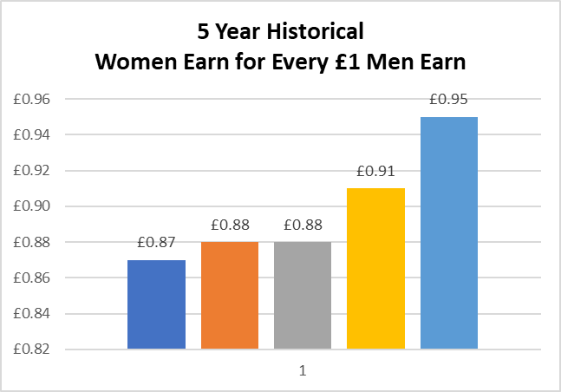

A graph showing the pay gap over the last 5 years

**Mean Gender Pay Gap**

The mean hourly rate is the average hourly wage across the entire organisation so the mean gender pay gap is a measure of the difference between women’s mean hourly wage and men’s mean hourly wage.

The 2023 mean gender pay gap for the Trust demonstrates that female colleagues are paid 20.7% less than male colleagues. This is an improvement of 2.6% in the mean pay gap from the previous year, as demonstrated in Table 1 below:

**Table 1 – Showing Mean Hourly Rates, the difference and percentage pay gap, from 2022 to 2023**

|  |  |  |  |
| --- | --- | --- | --- |
|  | Mean Hourly Rate 2022 | Mean Hourly Rate 2023 | Mean Hourly Rate 2022/23 Variation |
| Male | £23.95 | £22.50 | -£1.45 |
| Female | £17.83 | £17.84 | +0.01 |
| Difference | £5.12 | £4.66 | -£0.46 |
| Pay Gap | 23.3% | 20.7% | -2.6% |

**Median Gender Pay Gap**

The median hourly rate is calculated by ranking all employees from the highest paid to the lowest paid, and taking the hourly wage of the person in the middle, so the median gender pay gap is the difference between women’s median hourly wage (the middle paid woman) and men’s median hourly wage (the middle paid man).

The 2023 median gender pay gap for the Trust demonstrates that female colleagues are paid 5.2% less than male colleagues. This is an improvement of 4.1% in the median pay gap from the previous year, as demonstrated in Table 2 below:

**Table 2 – Showing Median Hourly Rates, the difference and percentage pay gap, from 2022 to 2023**

|  |  |  |  |
| --- | --- | --- | --- |
|  | Median Hourly Rate 2022 | Median Hourly Rate 2023 | Median Hourly Rate 2022/23 Variation |
| Male | £17.82 | £16.94 | -£0.88 |
| Female | £16.16 | £16.05 | -£0.11 |
| Difference | £1.66 | £0.88 | -£0.78 |
| Pay Gap | 9.3% | 5.2% | -4.1% |

**The Overall Bonus Pay Gap**

In our organisation, women earn £1 for every £1 that men earn when comparing median bonus pay.

**Mean Bonus Gender Pay Gap**

The 2023 mean bonus gender pay gap for the Trust demonstrates that female colleagues are paid 26.2% less than male colleagues in bonuses. This is an improvement of 50% in the mean bonus gender pay gap from the previous year, as demonstrated in Table 3 below:

**Table 3 – Showing Mean Bonus Rates, the difference and percentage pay gap, from 2022 to 2023**

|  |  |  |  |
| --- | --- | --- | --- |
|  | Mean Bonus Rate 2022 | Mean Bonus Rate 2023 | Mean Bonus Rate 2022/23 Variation |
| Male | £6,687.28 | £9,949.47 | +£3,262.19 |
| Female | £1,588.78 | £7,341.35 | +£5,752.57 |
| Difference | £5,098.50 | £2,608.12 | -£2,490.38 |
| Pay Gap | 76.2% | 26.2% | -50% |

**Median Bonus Gender Pay Gap**

The 2023 median bonus gender pay gap for the Trust demonstrates that female colleagues are paid the same as male colleagues in bonuses. This is an improvement of 87.3% in the median bonus gender pay gap from the previous year, as demonstrated in Table 4 below:

**Table 4 – Showing Median Bonus Rates, the difference and percentage pay gap, from 2022 to 2023**

|  |  |  |  |
| --- | --- | --- | --- |
|  | Median Bonus Rate 2022 | Median Bonus Rate 2023 | Median Bonus Rate 2022/23 Variation |
| Male | £3,536.91 | £4,770.18 | +£1,233.27 |
| Female | £450 | £4,770.18 | +£4,320.18 |
| Difference | £3,086.91 | £0.00 | -£3,086.91 |
| Pay Gap | 87.3% | 0% | -87.3% |

**Proportion of Males and Females Receiving a Bonus Payment**

Of the total workforce, 9.7% of males received bonuses compared to 1.7% of females. This is a decrease for males by 2.4% and a decrease in females of 6.6%, as demonstrated in Table 5 below:

**Table 5 – Showing Proportion of Males and Females Receiving a Bonus Payment from 2022 to 2023**

|  |  |  |  |
| --- | --- | --- | --- |
|  | Bonus Rate 2022 | Bonus Rate 2023 | Bonus Rate 2022/23 Variation |
| Male | 12.1% | 9.7% | -2.4% |
| Female | 8.3% | 1.7% | -6.6% |
| Difference | -3.8% | -8% | +4.2% |

**Proportion of Males and Females in Each Quartile Pay Band**

At the time the snapshot was taken the percentage of female colleagues was 77.8% and the percentage of male colleagues was 22.2%.

As shown in Table 6, below, the percentage of females in the all the quartiles is greater than the male percentage. In the lower, lower middle and upper middle quartiles the split is broadly representative of the Trust split. In the upper quartile there is a significant reduction of in females compared to males, although the number of female colleagues has increased in this quartile since the previous report.

**Table 6 – Showing Proportion of Males and Females in Each Quartile Pay Band from 2022 to 2023**

|  |  |  |  |  |  |  |
| --- | --- | --- | --- | --- | --- | --- |
| Quartile | 2022 | | | 2023 | | |
| Gender | Number | % | Gender | Number | % |
| Lower | Male | 288 | 19.1% | Male | 327 | 21.9%` |
| Female | 1231 | 80.9% | Female | 1163 | 78.1% |
| Lower Middle | Male | 281 | 18.6% | Male | 294 | 19.7% |
| Female | 1238 | 81.4% | Female | 1197 | 80.3% |
| Upper Middle | Male | 231 | 15.3% | Male | 226 | 15.2% |
| Female | 1278 | 84.7% | Female | 1266 | 84.9% |
| Upper | Male | 469 | 31.1% | Male | 475 | 31.8% |
| Female | 1041 | 68.9% | Female | 1017 | 68.2% |

**Conclusion**

The Trust continues to be committed to taking action in order to close the gender pay issues identified in this report.

Over the last 12 months we have strengthened our staff inclusion groups to provide them with a meaningful voice across the organisation that enables colleague to be heard on the issues that affect them.

Further actions in the coming year, which we hope will help to close the gender pay gap include reviewing the national EDI plan published in 2023 and undertake the recommended actions for Gender Pay Gap, which are:

1. Implement the Mend the Gap review recommendations for medical staff and develop a plan to apply those recommendations to senior non-medical workforce
2. Analyse data to understand pay gaps by protected characteristic and put in place an improvement plan. This will be tracked and monitored by NHS boards. Reflecting the maturity of current data sets, plans should be in place for sex and race by 2024, disability by 2025 and other protected characteristics by 2026.
3. Implement an effective flexible working policy including advertising flexible working options on organisations’ recruitment campaigns.

In addition locally we wish to:

1. Improve our inclusive approaches to recruitment, by reviewing our policies and processes and expanding our talent management offering.
2. Continue to work with our staff inclusion groups to provide them with a meaningful voice across the organisation that enables colleague to be heard on the issues that affect them.
3. Work with stakeholders to review the bonuses offered to staff to staff to ensure a fair and equitable approach.