**Gender Pay Gap Report 2025**

**Reporting on the snapshot date of 31 March 2024**

A photograph of the entrance to Kettering General Hospital

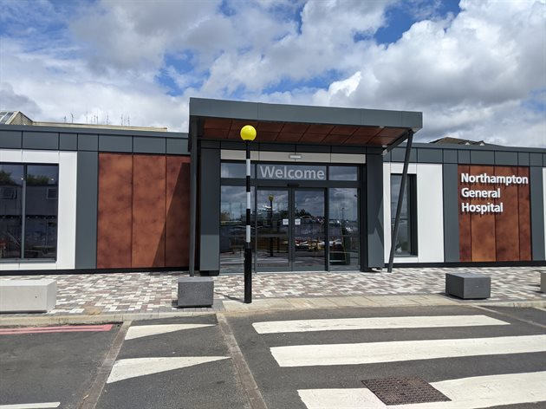

A photograph of the entrance to Northampton General Hospital

# **Contents**

Introduction………………………………………………………………….…3

NHS Pay Structure……………………………………………………………3

The Overall Pay Gap Across the UHN Group……………………………...4

Northampton General Hospital NHS Trust Pay Gap Information………..5

Kettering General Hospital NHS Foundation Trust Pay Gap Information.. …………………………………………………………………………………..8

Conclusion…………………………………………………………………....10

**Introduction**

The University Hospitals of Northamptonshire (UHN) Group brings together Kettering General Hospital (KGH) and Northampton General Hospital (NGH). The two hospital Trusts remain as separate organisations and this report gives details of the Gender Pay Gap of the two hospitals.

In line with the Equality Act 2010 (Gender Pay Gap Information Regulations 2017), Northampton General Hospital NHS Trust has undertaken gender pay gap reporting on the snapshot date of 31 March 2024.

We have calculated the following for our employees and workers:

* Snapshot of gender breakdown at UHN (page 3, see below)
* The mean gender pay gap (page 6 NGH, page 9 KGH)
* The median gender pay gap (page 6 NGH, page 9 KGH)
* The mean bonus gender pay gap (page 7 NGH, page 10 KGH)
* The median bonus gender pay gap (page 7 NGH, page 10 KGH)
* The proportion of genders receiving a bonus payment (page 7 NGH, page 10 KGH)
* The proportion of genders in each quartile pay band (page 8 NGH, page 11 KGH)

At the time the snapshot was taken UHN had the following employees:

|  |  |  |  |  |  |  |
| --- | --- | --- | --- | --- | --- | --- |
| **Gender** | **Northampton General** | | **Kettering General** | | **University Hospitals of Northamptonshire** | |
| Number | % | Number | % | Number | % |
| Female | 4870 | 77% | 3923 | 77% | 8793 | 77% |
| Male | 1474 | 23% | 1201 | 23% | 2675 | 23% |
| **Total** | **6,344** |  | **5,124** |  | **11,468** |  |

The ratio of male to female colleagues that the Trust has is commonplace for an acute district general hospital such as Northampton and Kettering.

The greatest proportion of colleagues at the two Trust are Nurses, Midwives and Healthcare Assistants and the majority of these colleagues are female. Data from the Nursing and Midwifery Council (NMC) supports this and in their mid-year update (1 April–30 September 2024) the NMC reported that 89% of the people on their register identified as female, while 11% identified as male.

**NHS Pay Structure**

The majority of colleagues at the Trust are on the national Agenda for Change Terms and Conditions of Service. The basic pay structure for these colleagues is across 8 pay bands and colleagues are assigned to one of these pay bands on the basis of job weight, as measured by the NHS Job Evaluation Scheme. Within each band there are a number of incremental pay progression points as agreed by the NHS National Staff Council.

Medical and Dental colleagues have different sets of Terms and Conditions of Service, depending on seniority. These too are set across a number of pay scales, for basic pay, which have varying numbers of thresholds within them.

There are separate arrangements for Very Senior Managers, such as Chief Executives, Directors and other senior managers who are not on an Agenda for Change Terms and Conditions of Service

As a public sector organisation, some of the services that are provided are on a 24/7 basis and therefore colleagues that work unsocial hours, participate in on-call rotas and work on general public holidays will also be in receipt of enhanced pay in addition to their basic pay. This mainly applies to clinical colleagues who work in ward areas along with non-clinical senior managers, who participate in the Senior Manager/Executive on-call rota and non-clinical colleagues who provide 24/7 services such as Estates and auxiliary colleagues.

The Trust does have a number of clinical departments that do not provide 24/7 such as clinics and outpatient areas and therefore these colleagues roles may not attract enhancements.

**The Overall Pay Gap Across the UHN Group**

When comparing the median hourly pay:

* At Northampton General Hospital our female colleagues earn 95p for every £1 that male colleagues earn. This is unchanged from the previous year.
* At Kettering General Hospital our female colleagues earn 90p for every £1 that male colleagues earn. This is an improvement from the previous year where it was 89p for every £1.

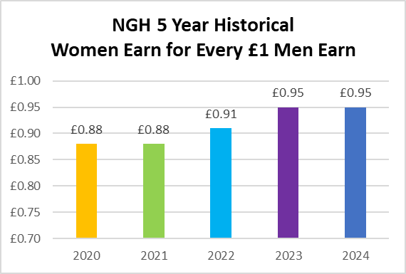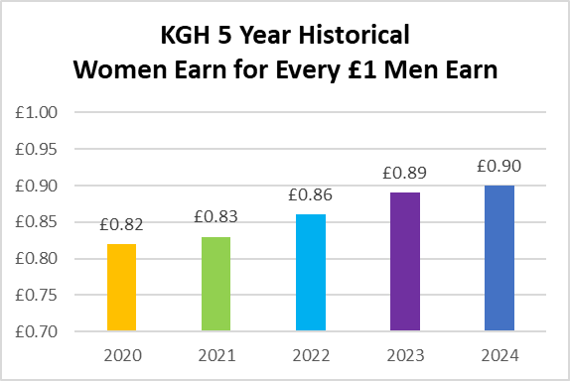

Graph 1 & 2 - Two graphs showing the pay gap for NGH and KGH over the past 5 years

Taking the average of the two, the overall Gender Pay Gap across University Hospitals of Northamptonshire Group is female Colleagues earn 92.5p (rounded up to 93p) for every £1 that male colleagues earn.

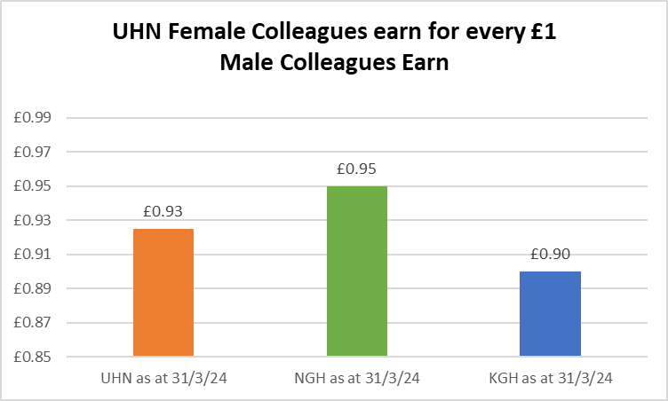

Graph 3 - A graph showing the pay gap for UHN

**Northampton General Hospital NHS Trust Pay Gap Information**

**Mean Gender Pay Gap**

The mean hourly rate is the average hourly wage across the entire organisation so the mean gender pay gap is a measure of the difference between women’s mean hourly wage and men’s mean hourly wage.

The 2024 mean gender pay gap for the Trust demonstrates that female colleagues are paid 18.1% % less than male colleagues. This is an improvement of 2.6% in the mean pay gap from the previous year, as demonstrated in Table 1 below:

**Table 1 – Showing Mean Hourly Rates, the difference and percentage pay gap, from 2023 to 2024**

|  |  |  |  |
| --- | --- | --- | --- |
|  | Mean Hourly Rate 2023 | Mean Hourly Rate 2024 | Mean Hourly Rate 2023/24 Variation |
| Male | £22.50 | £23.05 | £0.55 |
| Female | £17.84 | £18.88 | £1.04 |
| Difference | £4.66 | £4.17 | -£0.49 |
| Pay Gap | 20.7% | 18.1% | -2.6% |

**Median Gender Pay Gap**

The median hourly rate is calculated by ranking all employees from the highest paid to the lowest paid, and taking the hourly wage of the person in the middle, so the median gender pay gap is the difference between women’s median hourly wage (the middle paid woman) and men’s median hourly wage (the middle paid man).

The 2024 median gender pay gap for the Trust demonstrates that female colleagues are paid 4.9% less than male colleagues. This is an improvement of 0.3% in the median pay gap from the previous year, as demonstrated in Table 2 below:

**Table 2 – Showing Median Hourly Rates, the difference and percentage pay gap, from 2023 to 2024**

|  |  |  |  |
| --- | --- | --- | --- |
|  | Median Hourly Rate 2023 | Median Hourly Rate 2024 | Median Hourly Rate 2023/24 Variation |
| Male | £16.94 | £17.83 | £0.89 |
| Female | £16.05 | £16.97 | £0.92 |
| Difference | £0.88 | £0.86 | -£0.02 |
| Pay Gap | 5.2% | 4.9% | -0.3% |

**Mean Bonus Gender Pay Gap**

The 2024 mean bonus gender pay gap for the Trust demonstrates that female colleagues are paid 20.7% less than male colleagues in bonuses. This is an improvement of 5.5% in the mean bonus gender pay gap from the previous year, as demonstrated in Table 3 below:

**Table 3 – Showing Mean Bonus Rates, the difference and percentage pay gap, from 2023 to 2024**

|  |  |  |  |
| --- | --- | --- | --- |
|  | Mean Bonus Rate 2023 | Mean Bonus Rate 2024 | Mean Bonus Rate 2023/24 Variation |
| Male | £9,949.47 | £9,065.00 | -£884.47 |
| Female | £7,341.35 | £7,188.78 | -£152.57 |
| Difference | £2,608.12 | £1,876.22 | -£731.90 |
| Pay Gap | 26.2% | 20.7% | -5.5% |

**Median Bonus Gender Pay Gap**

The 2024 median bonus gender pay gap for the Trust demonstrates that female colleagues are paid 31.9% less than male colleagues in bonuses. This is an deterioration of 31.9% in the median bonus gender pay gap from the previous year, as demonstrated in Table 3 below:

**Table 4 – Showing Median Bonus Rates, the difference and percentage pay gap, from 2023 to 2024**

|  |  |  |  |
| --- | --- | --- | --- |
|  | Median Bonus Rate 2023 | Median Bonus Rate 2024 | Median Bonus Rate 2023/24 Variation |
| Male | £4,770.18 | £8,359.07 | £3,5880.89 |
| Female | £4,770.18 | £5,688.53 | £918.35 |
| Difference | £0.00 | £2,670.54 | £2670.54 |
| Pay Gap | 0% | 31.9% | 31.9% |

**Proportion of Males and Females Receiving a Bonus Payment**

Of the total workforce of 6344 colleagues, 2.3% of males received bonuses compared to 0.3% of females. This is a decrease for males by 7.4% and a decrease in females of 1.4%, as demonstrated in Table 5 below:

**Table 5 – Showing Proportion of Males and Females Receiving a Bonus Payment from 2023 to 2024**

|  |  |  |  |
| --- | --- | --- | --- |
|  | Bonus Rate 2023 | Bonus Rate 2024 | Bonus Rate 2023/24 Variation |
| Male | 9.7% | 2.3% | -7.4% |
| Female | 1.7% | 0.3% | -1.4% |
| Difference | -8% | -2% | -6% |

**Proportion of Males and Females in Each Quartile Pay Band**

At the time the snapshot was taken the percentage of female colleagues was 77% and the percentage of male colleagues was 23%.

As shown in Table 6, below, the percentage of females in the all the quartiles is greater than the male percentage. In the lower and lower middle quartiles the split is broadly representative of the Trust split. In the upper middle quartile there is an increase in the number of females compared to males, however in the upper quartile there is a significant reduction of in females compared to males.

**Table 6 – Showing Proportion of Males and Females in Each Quartile Pay Band from 2023 to 2024**

|  |  |  |  |  |  |  |
| --- | --- | --- | --- | --- | --- | --- |
| Quartile | 2023 | | | 2024 | | |
| Gender | Number | % | Gender | Number | % |
| Lower | Male | 327 | 21.9% | Male | 352 | 22.2% |
| Female | 1163 | 78.1% | Female | 1230 | 77.8% |
| Lower Middle | Male | 294 | 19.7% | Male | 351 | 22.1% |
| Female | 1197 | 80.3% | Female | 1237 | 77.9% |
| Upper Middle | Male | 226 | 15.2% | Male | 265 | 16.7% |
| Female | 1266 | 84.9% | Female | 1322 | 83.3% |
| Upper | Male | 475 | 31.8% | Male | 506 | 31.9% |
| Female | 1017 | 68.2% | Female | 1081 | 68.1% |

**Kettering General Hospital Foundation NHS Trust Pay Gap Information**

**Mean Gender Pay Gap**

The mean hourly rate is the average hourly wage across the entire organisation so the mean gender pay gap is a measure of the difference between women’s mean hourly wage and men’s mean hourly wage.

The 2024 mean gender pay gap for the Trust demonstrates that female colleagues are paid 26.01% less than male colleagues. This is an improvement of 1.5% in the mean pay gap from the previous year, as demonstrated in Table 1 below:

**Table 1 – Showing Mean Hourly Rates, the difference and percentage pay gap, from 2023 to 2024**

|  |  |  |  |
| --- | --- | --- | --- |
|  | Mean Hourly Rate 2023 | Mean Hourly Rate 2024 | Mean Hourly Rate 2023/24 Variation |
| Male | £23.78 | £25.11 | £1.33 |
| Female | £17.24 | £18.58 | £1.34 |
| Difference | £6.54 | £6.53 | -£0.01 |
| Pay Gap | 27.5% | 26.0% | -1.5% |

**Median Gender Pay Gap**

The median hourly rate is calculated by ranking all employees from the highest paid to the lowest paid, and taking the hourly wage of the person in the middle, so the median gender pay gap is the difference between women’s median hourly wage (the middle paid woman) and men’s median hourly wage (the middle paid man).

The 2024 median gender pay gap for the Trust demonstrates that female colleagues are paid 10.3% less than male colleagues. This is an improvement of 1.2% in the median pay gap from the previous year, as demonstrated in Table 2 below:

**Table 2 – Showing Median Hourly Rates, the difference and percentage pay gap, from 2023 to 2024**

|  |  |  |  |
| --- | --- | --- | --- |
|  | Median Hourly Rate 2023 | Median Hourly Rate 2024 | Median Hourly Rate 2023/24 Variation |
| Male | £17.20 | £18.41 | £1.21 |
| Female | £15.23 | £16.52 | £1.29 |
| Difference | £1.97 | £1.89 | -£0.08 |
| Pay Gap | 11.5% | 10.3% | -1.2% |

**Mean Bonus Gender Pay Gap**

The 2024 mean bonus gender pay gap for the Trust demonstrates that female colleagues are paid 14.7% less than male colleagues in bonuses. This is an deterioration of 3.7% in the mean bonus gender pay gap from the previous year, as demonstrated in Table 3 below:

**Table 3 – Showing Mean Bonus Rates, the difference and percentage pay gap, from 2023 to 2024**

|  |  |  |  |
| --- | --- | --- | --- |
|  | Mean Bonus Rate 2023 | Mean Bonus Rate 2024 | Mean Bonus Rate 2023/24 Variation |
| Male | £7,532.31 | £7,308.69 | -£223.62 |
| Female | £6,706.96 | £6,232.07 | -£474.89 |
| Difference | £825.35 | £1,076.62 | £251.27 |
| Pay Gap | 11.0% | 14.7% | 3.7% |

**Median Bonus Gender Pay Gap**

The 2024 median bonus gender pay gap for the Trust demonstrates that female colleagues are paid 0% less than male colleagues in bonuses. This remains unchanged from the previous year, as demonstrated in Table 3 below:

**Table 4 – Showing Median Bonus Rates, the difference and percentage pay gap, from 2023 to 2024**

|  |  |  |  |
| --- | --- | --- | --- |
|  | Median Bonus Rate 2023 | Median Bonus Rate 2024 | Median Bonus Rate 2023/24 Variation |
| Male | £4,468.60 | £4,589.28 | £120.68 |
| Female | £4,468.60 | £4,589.28 | £120.68 |
| Difference | £0.00 | £0.00 | £0.00 |
| Pay Gap | 0% | 0% | 0% |

**Proportion of Males and Females Receiving a Bonus Payment**

Of the total workforce of 5124 colleagues, 7.8% of males received bonuses compared to 0.93% of females. This is a decrease for males by 0.1% and a no change for females, as demonstrated in Table 5 below:

**Table 5 – Showing Proportion of Males and Females Receiving a Bonus Payment from 2023 to 2024**

|  |  |  |  |
| --- | --- | --- | --- |
|  | Bonus Rate 2023 | Bonus Rate 2024 | Bonus Rate 2023/24 Variation |
| Male | 7.9% | 7.8% | -0.1% |
| Female | 0.9% | 0.9% | 0% |
| Difference | 7% | -6.9% | -0.1% |

**Proportion of Males and Females in Each Quartile Pay Band**

At the time the snapshot was taken the percentage of female colleagues was 77% and the percentage of male colleagues was 23%.

As shown in Table 6, below, the percentage of females in the all the quartiles is greater than the male percentage. In the lower and lower middle quartiles the split is broadly representative of the Trust split. In the upper middle quartile there is an increase in the number of females compared to males, however in the upper quartile there is a significant reduction of in females compared to males.

**Table 6 – Showing Proportion of Males and Females in Each Quartile Pay Band from 2023 to 2024**

|  |  |  |  |  |  |  |
| --- | --- | --- | --- | --- | --- | --- |
| Quartile | 2023 | | | 2024 | | |
| Gender | Number | % | Gender | Number | % |
| Lower | Male | 232 | 18.5% | Male | 240 | 18.8% |
| Female | 1023 | 81.5% | Female | 1038 | 81.2% |
| Lower Middle | Male | 252 | 20.1% | Male | 272 | 21.2% |
| Female | 1004 | 79.9% | Female | 1010 | 78.8% |
| Upper Middle | Male | 218 | 17.4% | Male | 215 | 16.8% |
| Female | 1038 | 82.6% | Female | 1067 | 83.2% |
| Upper | Male | 471 | 37.5% | Male | 474 | 37.0% |
| Female | 786 | 62.5% | Female | 808 | 63.0% |

**Conclusion**

As this report demonstrates at both Northampton General Hospital and Kettering General Hospital our female colleagues have lower median average hourly rates of pay when compared to our male colleagues. Resulting in a rate of 95p and 90p respectively, at each Trust, for every £1 that a male colleague earn.

In relation to bonus pay, Northampton General Hospital difference is 31.9%, for the median average and Kettering General Hospital is currently 0% different. This is attributable to the Clinical Excellence Awards for Medical and Dental Staff and the male Consultants receiving them. Going forward there will be no new awards as agreed as part of the 2024 Consultant pay deal. However historical ones will remain until such time as the recipient leaves/retires from their respective organisation.

**Gender Pay Gap Action Plan**

The Trust continues to be committed to taking action in order to close the gender pay issues identified in this report.

**What we have achieved**

Over the last 12 months we have:

* Strengthened our staff inclusion groups to provide them with a meaningful voice across the organisation that enables colleagues to be heard on the issues that affect them.

**Action Plan 2024/25**

Further actions in the coming year, which we hope will help to close the gender pay gap include reviewing the national EDI plan published in 2023 and undertake the recommended actions for Gender Pay Gap, which are:

1. Implementing the Mend the Gap review recommendations for medical staff and develop a plan to apply those recommendations to senior non-medical workforce : [Mend the Gap: The Independent Review into Gender Pay Gaps in Medicine in England - December 2020](https://assets.publishing.service.gov.uk/media/5fd893a7e90e076631fb2286/Gender_pay_gap_in_medicine_review.pdf)
2. Analysing data to understand pay gaps by protected characteristic and put in place an improvement plan. This will be tracked and monitored by NHS boards. Reflecting the maturity of current data sets, plans should be in place for sex and race by 2024, disability by 2025 and other protected characteristics by 2026.
3. Continue improving our flexible working policy including advertising flexible working options on organisations’ recruitment campaigns.
4. Improve our inclusive approaches to recruitment, by reviewing our policies and processes and expanding our talent management offering.
5. Continue to work with our staff inclusion groups to provide them with a meaningful voice across the organisation that enables colleague to be heard on the issues that affect them.
6. Work with stakeholders to review the bonuses offered to staff to ensure a fair and equitable approach