**Workforce Race Equality Standard (WRES) Data**

2022

**Percentage of staff members at NGH who are White, BME or have not stated their ethnicity.**

*Total Workforce = 5805*

*White = 3906*

*BME = 1757*

*Not stated = 142*

**AFC Bands/VSM**

**Medical & Dental**

**White BME Not Stated**

Bands 1-4 **81.42% 16.65% 2.02%**

Bands 5-7 **60.74% 36.75% 2.51%**

Bands 8A-VSM **86.22% 12.37% 1.41%**

**White BME Not Stated**

Consultants **46.72% 49.03% 4.25%**

Non-Consultant Career Grade **17.58% 76.37% 6.05%**

Trainee Grades **30.13% 67.25% 2.62%**

**Relative likelihood of BME staff entering the formal disciplinary process compared to White staff**

**Percentage of staff experiencing harassment, bullying or abuse from other colleagues in the last 12 months**

**Percentage of staff experiencing harassment, bullying or abuse from patients, relatives or the public in the last 12 months**

**Relative likelihood of White staff accessing non-mandatory training and CPD compared to BME staff**

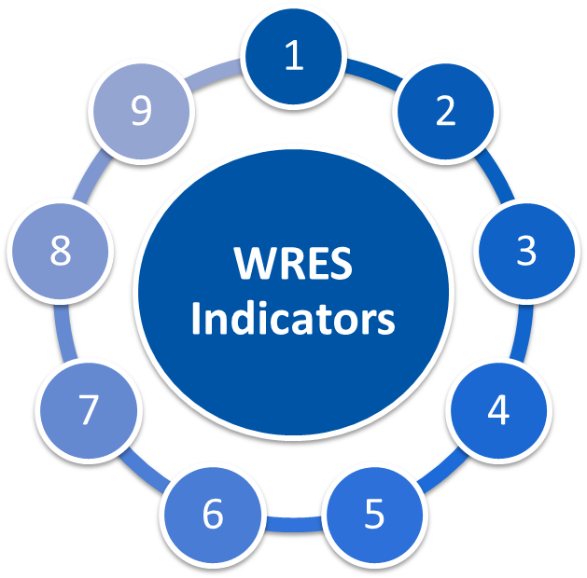

**0.62**

**Improvement of 1.18 from 2021**

**1.00**

**Improvement of 0.52 from 2021**

**0.93**

**Unchanged from 2021**

**BME -10%**

**White 13%**

**An improvement of 11.5% from 2021**

**BME 25%**

**White 9%**

**3% deterioration for BME staff**

**BME 40%**

**White 56%**

**Unchanged for BME staff**

**BME 31%**

**White 31%**

**1% improvement for BME staff**

**BME 31%**

**White 29%**

**1% deterioration for BME staff**

**Percentage difference between the organisations’ Board voting membership and its overall workforce**

**Percentage of staff who have personally experienced discrimination at work from Manager/Team leader**

**Percentage of staff believing the hospital provides equal opportunities for career progression or promotion**

**Relative likelihood of White staff being appointed from shortlisting compared to BME staff**

**What are we doing / plan to do within the hospital:**

2022

**Workforce Race Equality Standard (WRES) Data**

**Specific Board Actions:**

1

1

Working with our Group partners, develop a REACH career conversations network, with senior leaders supporting and mentoring REACH staff at Band 8A to support their development.

Review the impact of the Inclusive Recruitment Champion process and seek to further debias the recruitment and selection process.

2

Continue to support the RCN Cultural Ambassador programme to support REACH staff during formal and informal HR process to ensure a space/ atmosphere of safety, transparency and support that is offered to the staff.

2

Support the ICB in the roll out of Reverse Mentoring for race and LGTQ+ with a minimum of three Executive Directors being mentored by colleagues across the system

Working with system and regional colleagues, actively support and develop pathways for greater Executive and Non-Executive representation on the Trust Board of Directors

3

3

Work with staff to address increases in violence, aggression, bullying, harassment and discrimination from patients, service users, relatives and carers.

4

4

Working with our Group partners, develop a REACH career conversations network, with senior leaders supporting and mentoring REACH staff at Band 8A to support their development.

Working with our Group partners, develop a REACH career conversations network, with senior leaders supporting and mentoring REACH staff at Band 8A to support their development.

5

Working with key internal and external stakeholders, begin work on an Anti-Racism strategy for the University Hospitals of Northamptonshire.

5

Deliver the ‘Dedicated to Excellence’ Culture and Leadership Programme, ensuring diverse representation from across the Group to build psychological safety and ensure all staff voices are heard